

Course title: Discrete Mathematics
Course code: CSE106
Section: 17
Semester: Fall 24
Report Paper of Mini Project

Submitted by: Group-5(THEOREM THINKERS)

ID: 2024-3-60-135, 2024-3-60-134, 2024-3-60-128

Submitted to:
Instructor
Nishat Tasnim
Dept. of Computer Science and Engineering
East West University

Introduction: In computer science, graphs are used to represent networks like social media, transportation systems, or websites. A graph has vertices (or nodes) and edges (connections between nodes). The degree of a vertex shows how many edges are connected to it. There are two types of degrees: in-degree and out-degree. The in-degree counts the edges pointing towards a vertex, while the out-degree counts the edges pointing away from it. In this project, we generate a random graph and calculate the in-degree and out-degree for each vertex.

Methodology: In this project, a simple graph generation program in C was created to calculate the in-degree and out-degree for each vertex. The steps followed are:
- Graph Generation:
A random graph is created using an adjacency matrix. In this matrix, the value 1 means there is an edge between two vertices, and 0 means there is no connection. The number of vertices, n, is given by the user.
- In-Degree Calculation:
The in-degree for each vertex is calculated by counting how many edges are pointing towards it. This is done by adding the values in each column of the adjacency matrix, as each column represents incoming edges.
- Out-Degree Calculation:
The out-degree is calculated by counting how many edges are pointing away from each vertex. This is done by adding the values in each row of the adjacency matrix, as each row represents outgoing edges.
- Performance Measurement:
The time taken to generate the graph and calculate the degrees is measured using the clock() function from the C standard library. The time is shown in milliseconds.
- Memory Management:
Dynamic memory allocation is used to create the adjacency matrix, and memory is freed after use to prevent memory leaks.
Degrees and time complexity:
• In-Degree and Out-Degree:
The in-degree of a vertex is found by adding the values in its column of the adjacency matrix, which represents edges pointing to it. The out-degree is found by adding the values in its row, which represents edges pointing away from it.
• Time Complexity:
The adjacency matrix has n x n elements, where n is the number of vertices. To calculate the in-degree, we need to check every column for all vertices, which takes O(n²) time. Similarly, calculating the out-degree requires checking every row for all vertices, also taking O(n²) time. Graph generation also involves assigning values to all elements in the matrix, which takes O(n²) time. Therefore, the total time complexity of the program is O(n²).
Program Output:
For n = 1000 vertices,
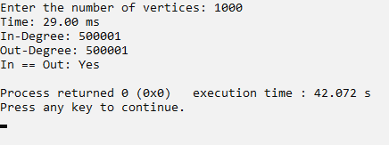
For n = 2000 vertices,
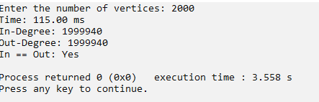

For n = 3000 vertices ,
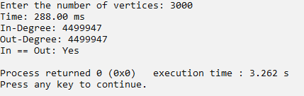

For n = 4000 vertices,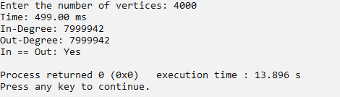

For n = 5000 vertices
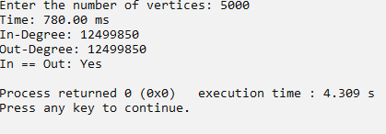

Graph showing computational time vs n:
number of vertices (n) | Computational time (ms)
1000 | 29.00
2000 | 115.00
3000 | 288.00
4000 | 499.00
5000 | 780.00

Graph: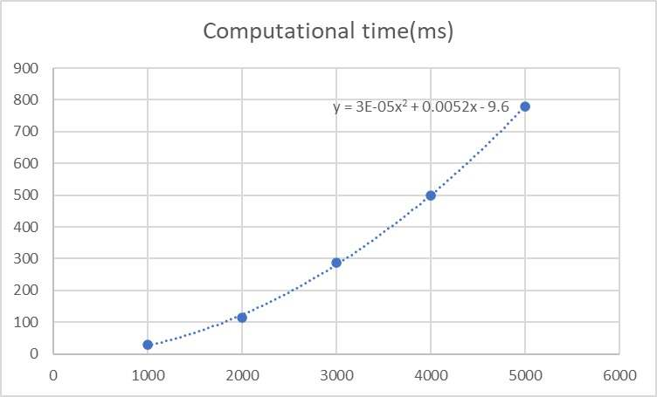

Result:
The program generates a random graph and calculates the in-degree and out-degree for each vertex. After running the program:
- The graph was successfully generated with random connections between vertices.
- The in-degree and out-degree for each vertex were calculated and displayed.
- The program's execution time was measured and showed how long it took to generate the graph and calculate the degrees. For example, it might take around 28.00ms to handle 1000 vertices.
Time Complexity:
The program's time complexity is O(n²). This is because the graph generation and degree calculations involve nested loops. Each loop runs n times, where n is the number of vertices. As a result, the time taken grows quadratically with the number of vertices.
For the equation Y = 3E-05n² + 0.0052n - 9.6, the highest term is n². Since the time complexity is determined by the term with the highest growth rate, the time complexity for calculating the equation is also O(n²). This means that the time required to compute Y increases quadratically as n increases.
Conclusion: This project generated a random graph and calculated the in-degree and out-degree for each vertex. The program worked as expected, with the time complexity of O(n²) due to the nested loops. The calculations were correct, and the results matched the expected behavior. This project shows how graph generation and degree calculations can be efficiently performed, and it can be expanded for more complex tasks in the future.
Future Work.
In the future, this project can be improved to work with larger graphs and run faster. It could also include features like graph visualization and updates. Real-life uses include studying social media connections, mapping roads, or analyzing relationships in websites or organizations.

